Name : Tushar Pathak
Registration Number : 230905396
Roll Number : CSE6B-48
Week Num : 5

LAB 5 : INTRODUCTION TO FLEX

Q1) Count the number of vowels and consonants in the given input.

Code:

%{
#include <stdio.h>
int v = 0, c = 0;
%}

%%
[aeiouAEIOU] { v++; }
[a-zA-Z] { c++; }
.|\n { }
%%

int main() {
yylex();
printf("Vowels = %d\nConsonants = %d\n", v, c);
return 0;
}

int yywrap() {
return 1;
}

Output:
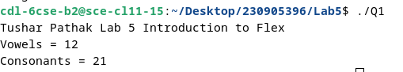
Q2) Count the number of words, characters, blanks and lines in a given text.

Code:

%{
#include <stdio.h>
int words = 0, chars = 0, blanks = 0, lines = 0;
%}

%%
\n { lines++; chars++; }
[ \t]+ { blanks += yyleng; chars += yyleng; }
[^ \t\n]+ { words++; chars += yyleng; }
. { chars++; }
%%

int main() {
yylex();
printf("Words = %d\nCharacters = %d\nBlanks = %d\nLines = %d\n",
words, chars, blanks, lines);
return 0;
}

int yywrap() {
return 1;
}

Output:
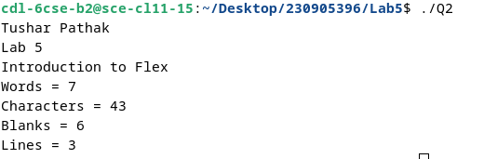
Q3) Find the number of positive integer, negative integer, positive floating positive number and negative floating point number

Code:

%{
#include <stdio.h>
int pi = 0, ni = 0, pf = 0, nf = 0;
%}

%%
[+]?[0-9]+\.[0-9]+ { pf++; }
-[0-9]+\.[0-9]+ { nf++; }
[+]?[0-9]+ { pi++; }
-[0-9]+ { ni++; }
.|\n ;
%%

int main() {
yylex();
printf("Positive Integers = %d\nNegative Integers = %d\n", pi, ni);
printf("Positive Floats = %d\nNegative Floats = %d\n", pf, nf);
return 0;
}

int yywrap() {
return 1;
}

Output:
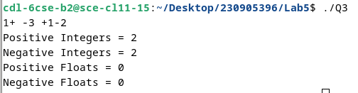
Q4) Given a input C file, replace all scanf with READ and printf with WRITE statements also find the number of scanf and printf in the file.

Code:

%{
#include <stdio.h>
int sc = 0, pr = 0;
FILE *yyin;
%}

%%
scanf { printf("READ"); sc++; }
printf { printf("WRITE"); pr++; }
.|\n { printf("%s", yytext); }
%%

int main() {
yyin = fopen("input.c", "r");
if (!yyin) {
perror("input.c");
return 1;
}
yylex();
printf("\nScanf count = %d\nPrintf count = %d\n", sc, pr);
return 0;
}
int yywrap() { return 1; }

Input file:
#include <stdio.h>

int main() {
int i;
char msg[] = "Done";
int d=1;
for (i = 1; i <= 10; i++) { // loop
if (i % 2 == 0 && !d) { // decision
printf("%d is Even\n", i);

} else {
printf("%d is Odd\n", i);
d -=1;
}
}
printf("%s",msg);
return 0;
}

Output:
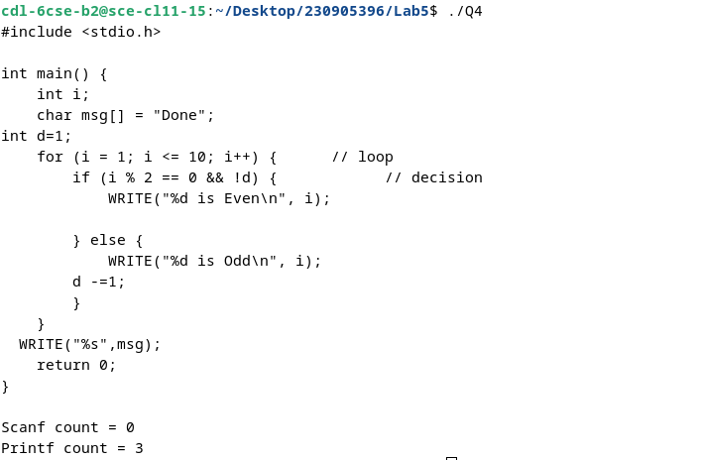

Q5) That changes a number from decimal to hexadecimal notation.

Code:

%{
#include <stdio.h>
#include <stdlib.h>
%}

%%
[0-9]+ {
int n = atoi(yytext);
printf("Decimal: %d Hexadecimal: %X\n", n, n);
}
\n ;
. ;
%%

int main() {
yylex();
return 0;
}

int yywrap() {
return 1;
}

Output:

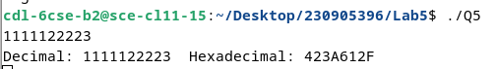

Q6) Convert uppercase characters to lowercase characters of C file excluding the characters present in the comment.

Code:

%{
#include <stdio.h>
#include <ctype.h>

FILE *yyin;
%}

%%
"/*"([^*]|\*+[^*/])*\*+"/" { printf("%s", yytext); } /* multi-line comment */
"//".* { printf("%s", yytext); } /* single-line comment */
[A-Z] { putchar(tolower(yytext[0])); }
.|\n { printf("%s", yytext); }
%%

int main() {
yyin = fopen("input.c", "r");
if (!yyin) {
perror("input.c");
return 1;
}
yylex();
return 0;
}

int yywrap() {
return 1;
}

Input file:
#INCLUDE <STDIO.H>
INT MAIN() {
INT I;
CHAR MSG[] = "DONE";
INT D=1;
FOR (I = 1; I <= 10; I++) { // LOOP
IF (I % 2 == 0 && !D) { // DECISION
PRINTF("%D IS EVEN\n", I);
} ELSE {
PRINTF("%D IS ODD\n", I);
D -=1;
}
}
PRINTF("%S",MSG);
RETURN 0;
}

Output:
